What happens when the government can no longer protect you. What happens when you need protection from the government? What happens when you can no longer protect yourself?

You are responsible for your own safety and protection. You may choose to provide that safety by handing the responsibility over to elected officials and paid public workers. This has worked well for many years, and I have nothing against this system. However, with the increased scrutiny of law enforcement officials comes a shortage in those jobs. Now, your decision to sub-contract your safety may have a negative impact. Response times may increase. Investigations may not get solved. So, again, whose job is it to protect you?

It’s yours. If you choose not to protect yourself, that is YOUR choice. Your choice to be a sheep should not affect other’s abilities to protect themselves. Look at Clive Bundy and the now the Snake River Ranchers. Without the means to protect themselves, they would have been victims of the government. Without the means to protect yourself, you may be a victim of the same, or of your fellow man. 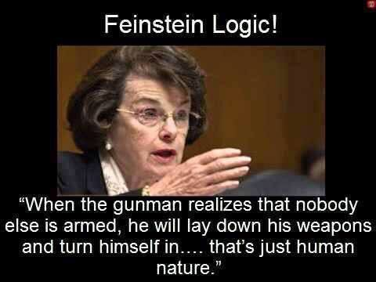

This may be the most absurd statement yet. This is like saying, when the speeding driver sees that everyone else is doing the speed limit, he will slow down. Well no, he’s in a hurry and you are in his way. Just like when a shooter wants to do something…he does. The laws won’t stop him, and neither will disarming yourself.

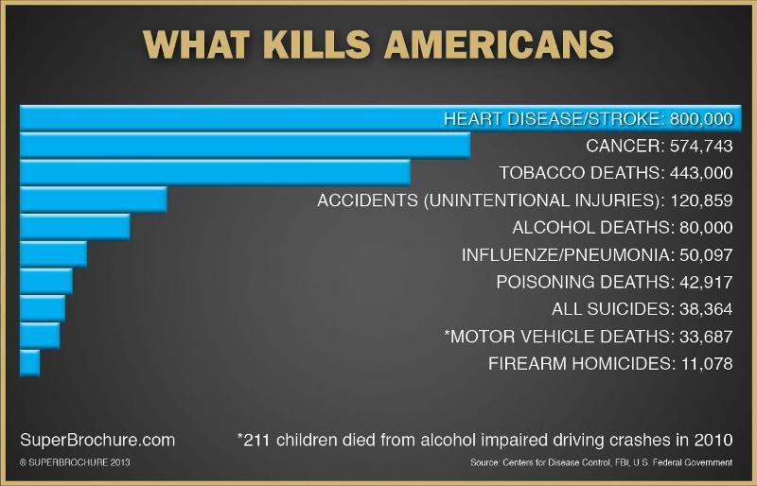

So are we really concerned about what is killing us? Why not outlaw unhealthy food? Oh, its our right to eat what we want? You don’t say?!

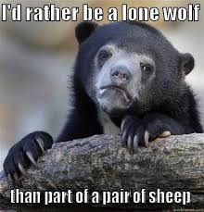

If only it were just a “pair” of sheep. Rather than thousands of sheep we really have. You want to protest the police that protect us, then you want to protest the guns that protect us. I don’t think many understand that protection is a right. If you get rid of the police and get rid of the guns, then what are you planning to invite in?

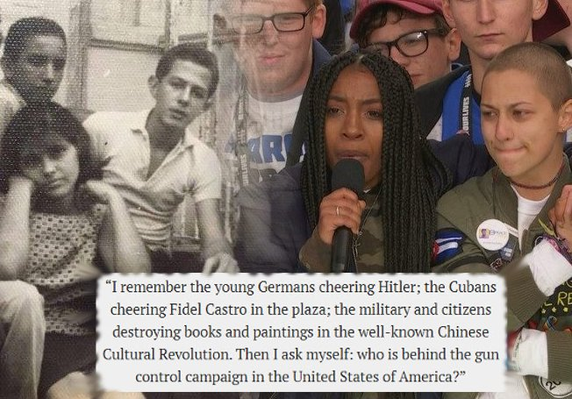

Exactly. Is this movement being led on by Russian, and other State-Level internet trolls. Are they hoping we destroy ourselves from within? If so, why?

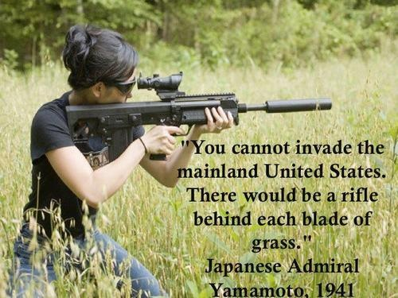

This is why. They know they can’t take us in a fight. Our military is full of people who grew up around guns and are comfortable shooting them. Get rid of that and it erodes a portion of our readiness. Perhaps that gives them enough edge against our young men to win, or to arrive on our shores. Well right now, as you can see from the quote above, they wouldn’t consider it. Our insurgency would put those in the middle east to shame. We would organize and hit them hard. After traveling so far they would be spread thin and be easy pickings for our gun-toting Patriots! But, disarm the populace and no matter how tired they are when they arrive, they will have plenty of time to rest up while we hurl rocks and canned goods at them. Or while we hide in our houses and do as they say to avoid annihilation.

So you wanna take my guns?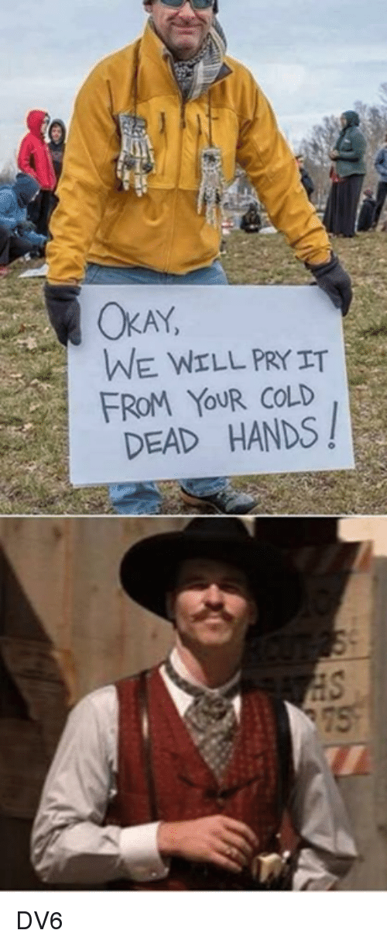

I’m your Huckleberry. Just how is it you plan to kill me and take it when you protested the police out of business and you are afraid of guns?

This will never stop. Once they outlaw guns, criminals will turn to knives. Then they will try to outlaw those as well. This is happening in the UK now. They already outlawed guns, and now they want to outlaw pocket knives. Now they are going after free speech by convicting a comedian of making a joke when his dog raised his paw to a TV show featuring footage of Hitler. He wasn’t saying hitler was good. He was saying wow, look at my evil dog. But the context didn’t matter.

So stop saying it worked for the UK. Well if we agreed with everything they did, we wouldn’t exist right now, we’d still be a part of them.

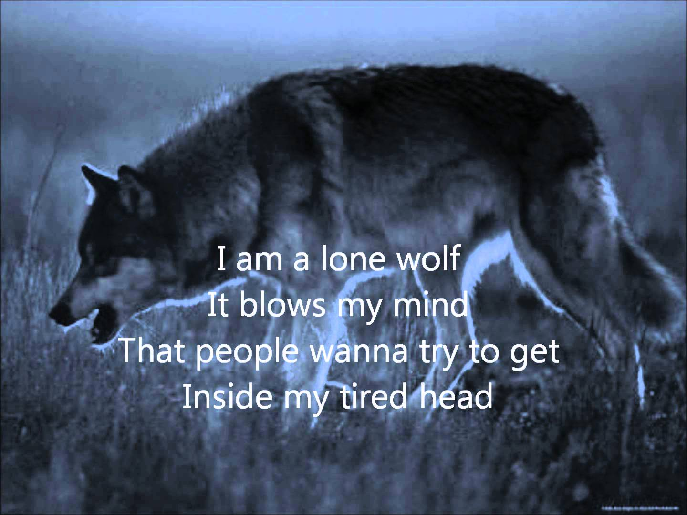

Something must be done to show that gun-free zones do not work and will never work. So I intend to break the law. Because that’s what the criminals will do. No matter your laws, when they decide to act, they will. Drugs have always been illegal, but that doesn’t stop people from getting drugs. Speeding is illegal, but people still drive fast. Fraud is illegal, but greed is a strong motivator. So I will be the lone wolf that helps demonstrate to the American Public that laws and signs won’t work. Only the ability to protect yourself will work. The Second Amendment was not “poorly written” it was drafted by the same men who drafted the rest of the Constitution. And no one is complaining about he protections and freedom it gives you. Especially the 1st amendment which allows you to spew your crazy gun-control thoughts.

You will soon see when the blood has been shed and the defenseless bodies stacked high. I will do what I must. No matter who is hurt, the collateral damage will be worth it.

I will be the change. I will be the revolutionary. I will be the history maker. I will fight. I will be the Lone Wolf.